**CREATE DATABASE AND POPULATE TABLES**

mysql –u root –p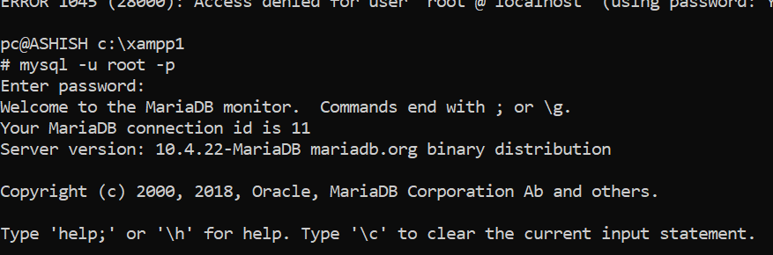

CREATE SCHEMA EMP_DEPT;

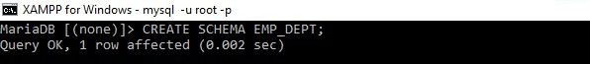

USE EMP_DEPT;

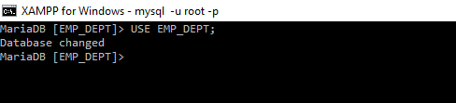

CREATE TABLE DEPARTMENT(DNO INT NOT NULL,

DNAME VARCHAR(50),

LOCATION VARCHAR(50) DEFAULT 'NEW DELHI',

PRIMARY KEY(DNO));

DESC DEPARTMENT;

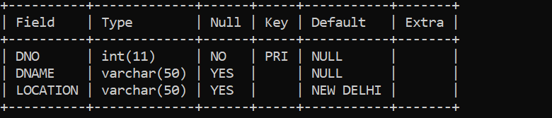

CREATE TABLE EMPLOYEE(ENO CHAR(3) NOT NULL,

ENAME VARCHAR(50) NOT NULL,

JOB_TYPE VARCHAR(50) NOT NULL,

S_ENO CHAR(3),

HIRE_DATE DATE NOT NULL,

DNO INT,

COMMISSION DECIMAL(10,2),

SALARY DECIMAL(7,2) NOT NULL,

PRIMARY KEY(ENO),

FOREIGN KEY(DNO) REFERENCES DEPARTMENT(DNO),

FOREIGN KEY(S_ENO) REFERENCES EMPLOYEE(ENO));

DESC EMPLOYEE;

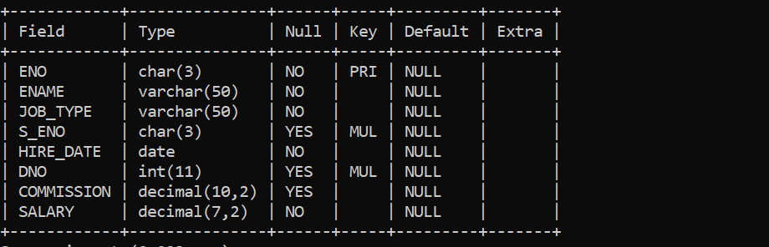

SHOW TABLES;

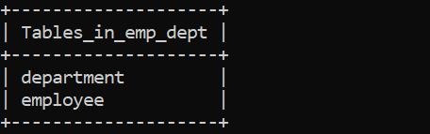

**DEPARTMENT TABLE**

INSERT INTO DEPARTMENT VALUES (‘20’,’CHEMISTRY’,’AGRA’);

INSERT INTO DEPARTMENT VALUES (‘30’,’physics’,PANIPAT’);

INSERT INTO DEPARTMENT VALUES (‘40’,’MATHS’,AGRA’);

INSERT INTO DEPARTMENT VALUES (‘50’,’HINDI’,’YAMUNA NAGAR’);

INSERT INTO DEPARTMENT VALUES (‘60’,’ACCOUNTS’,PRATAP NAGAR’);

INSERT INTO DEPARTMENT VALUES (‘70’,ACCOUNTS’,’SHIMLA’);

INSERT INTO DEPARTMENT VALUES (‘80’,HISTORY’,MANALI’);

INSERT INTO DEPARTMENT VALUES (‘90’,’ENGLISH’,’KULLU’);

INSERT INTO DEPARTMENT VALUES (‘100’,’ ECONOMICS’,CHANDIGARH’);

INSERT INTO DEPARTMENT VALUES (‘110’,’HINDI’,SHAHBAD’);

SELECT*FROM DEPARTMENT;

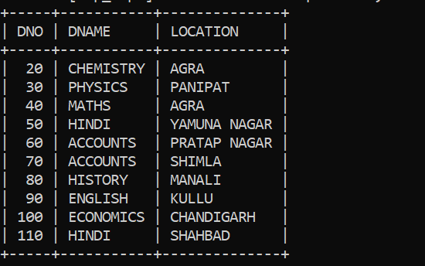

**EMPLOYEE TABLE**

INSERT INTO EMPLOYEE VALUES

('6','ANSHIKA','STUDENT','1','2003-01-11','70','110','220'),

('7','ANSHITA','STUDENT','1','2003-01-11','70','180','2850'),

('8','MUSKAN','STUDENT','1','2003-01-21','70','120','1500'),

('9','YOGITA','PROFESSOR','1','2002-01-21','70','2220','15002'),

('10','YOGANSHU','ASSISTANT','2','1981-01-21','70','22110','123002'),

('11','YOGANSHU','ASSISTANT','2','1981-21-21','70','22310','126102'),

('12','YOGANSH','CO ASSISTANT','2','1981-21-11','70','210','12202'),

('13','YOGESH','LAB ATTENDANT','2','1980-21-11','70','230','12234'), -> ('14','HIMANSHU','TEACHER','2','1980-21-15','70','2987','125678'),

('15','HANSRAJ','STUDENT','2','2011-11-15','70','2007','120000'),

('16','HEMA','STUDENT','6','2011-10-15','70','207','120230'),

('17','VINAY','PROFESSOR','7','2011-10-18','70','232','120232'),

('18','VINII','PROFESSOR','9','2010-10-18','70','235','199232'),

('19','VISHAKHA','PRINCIPAL','3','2010-10-19','70','232','192222'),

('20','VISHAL','WORKER','5','2010-10-09','70','2232','2234522'),

('21','VIKAS','HELPER','7','2010-10-19','70','292','22542'),

('22','RAMESH','HELPER','8','2011-10-19','80','234','567842');

SELECT*FROM EMPLOYEE;

